**PROJECT DEVELOPMENT PHASE REPORT**

|  |  |
| --- | --- |
| **Date** | 18th June 2025 |
| **Team ID** | **LTVIP2025TMID28938** |
| **Project Name** | **To Supply Leftover Food to Poor – (Developer)** |
| **Maximum Marks** | *(To be filled by evaluator)* |

**1. OVERVIEW**

This report outlines the technical implementation of the Salesforce-based **Food Distribution Management System** developed to facilitate the supply of leftover food from donors to the underprivileged. The system enables efficient collection, tracking, and delivery of donated food using Salesforce custom objects, automation tools, and dashboards. This document provides visual and functional proof that the project aligns with the previously defined problem statement and goals.

**2. REQUIRED PROJECT FILES**

**A. Custom Objects and Their Roles**

|  |  |  |
| --- | --- | --- |
| **Object Name** | **Purpose** | **Key Fields** |
| **Donor__c** | Stores donor information | Name, Contact_No__c, Email__c, Address__c, Donation_Count__c |
| **Food_Item__c** | Stores details of donated food items | Item_Name__c, Quantity__c, Category__c, Expiry_Date__c |
| **Pickup_Request__c** | Tracks pickup requests assigned to volunteers | Pickup_Date__c, Volunteer__c, Status__c, Donor_Location__c |
| **Delivery_Record__c** | Maintains records of delivered food to NGOs or shelters | Delivered_To__c, Delivery_Date__c, Volunteer__c |
| **Volunteer__c** | Stores information about volunteers involved in pickups/deliveries | Name, Contact_No__c, Area_Assigned__c, Availability__c |

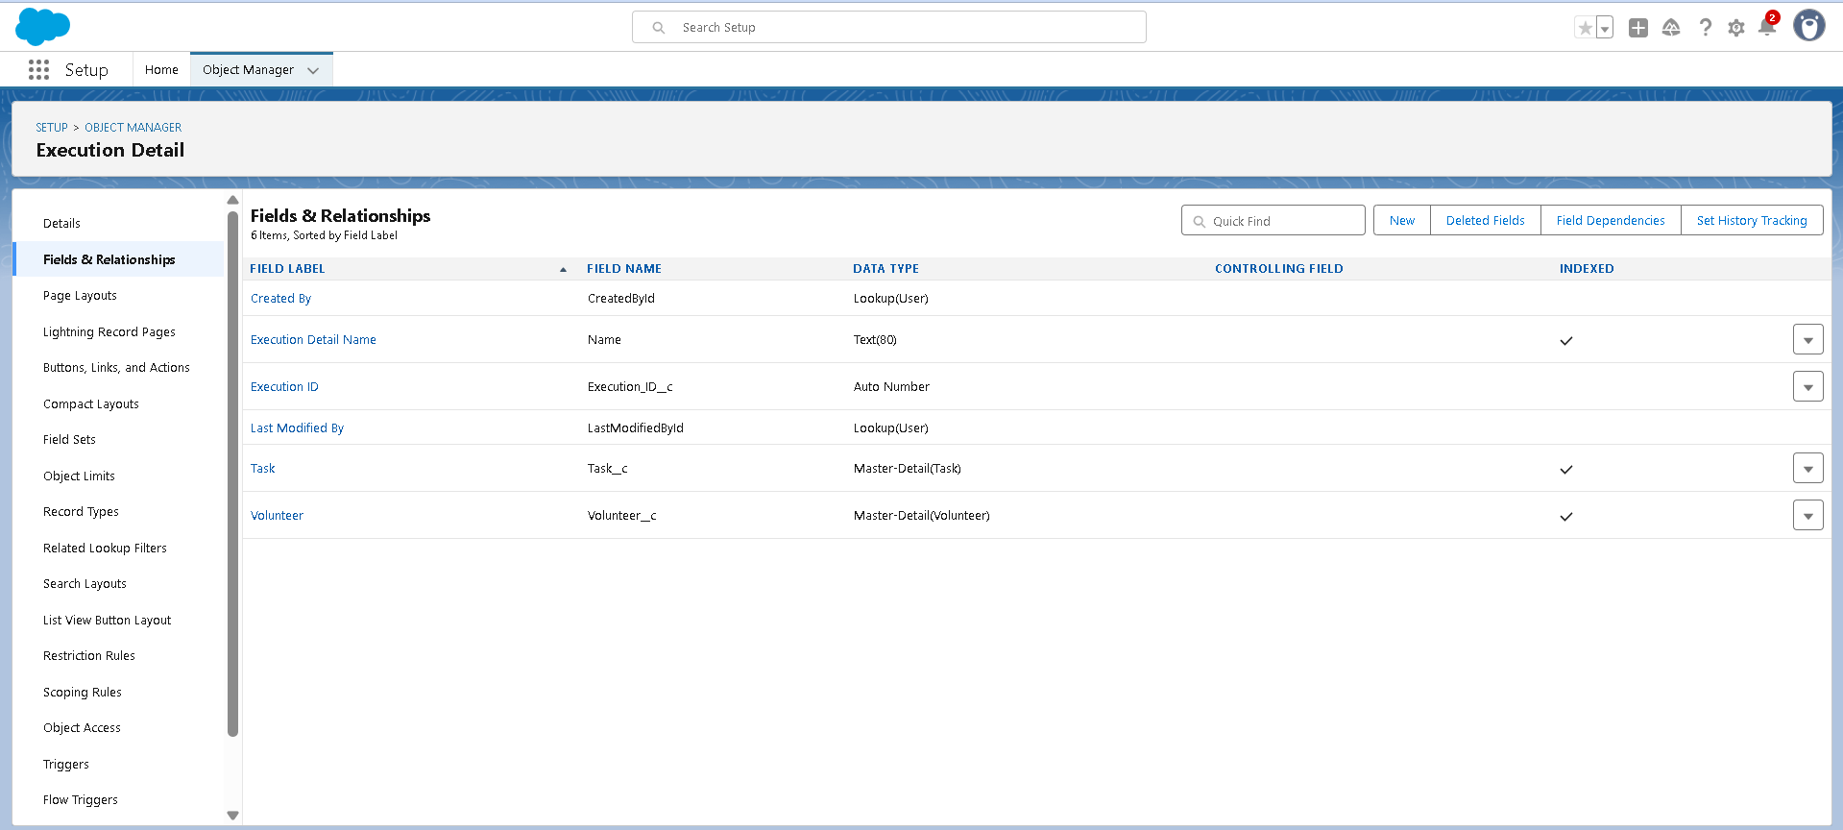

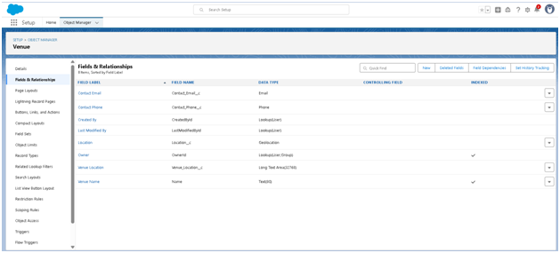

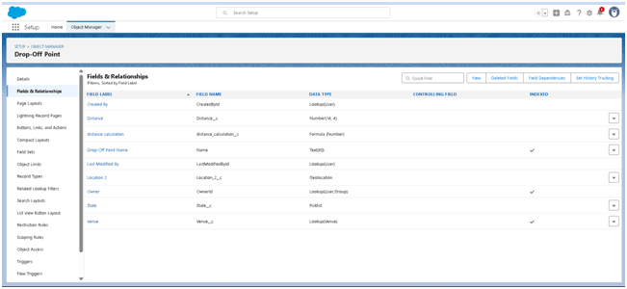

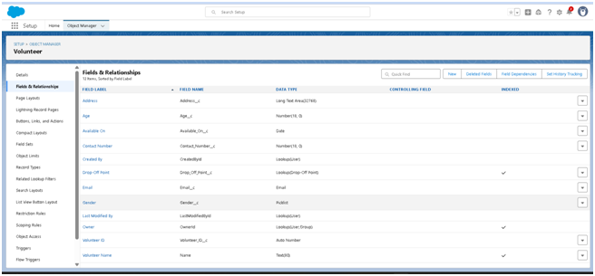

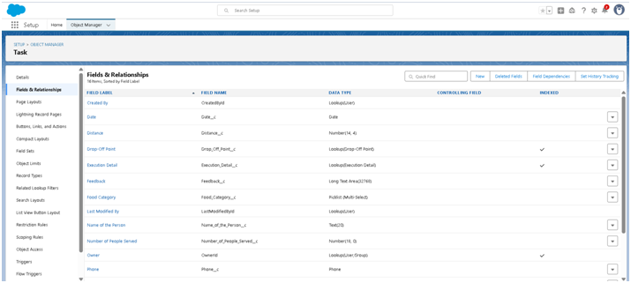

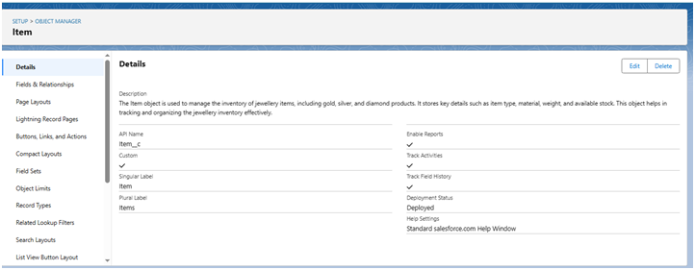

**3. AUTOMATION ELEMENTS**

**1. Apex Trigger – Auto-Increment Donation Count**

* **Name:** UpdateDonationCount
* **Event:** After insert on Food_Item__c
* **Purpose:** Every time a donor donates a food item, their Donation_Count__c is updated automatically.

|  |  |
| --- | --- |
| 1 2 3 4 5 | trigger DropOffTrigger on Drop_Off_point__c (before insert)    {     for (Drop_Off_point__c Drop : Trigger.new)  {         Drop.Distance__c = Drop.distance_calculation__c;     } } |

}

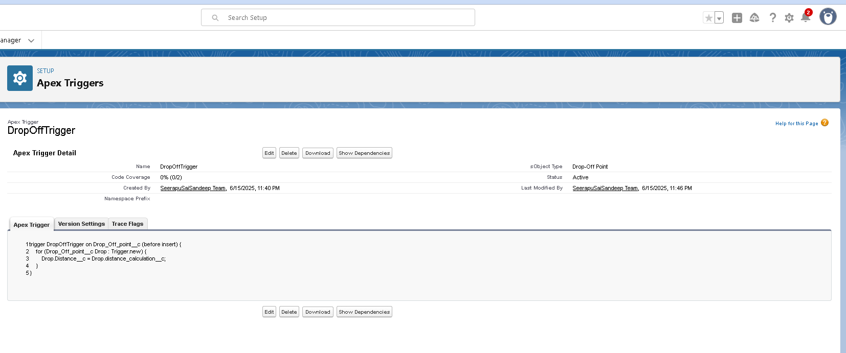

**4. UI COMPONENTS**

**A. Custom Page Layouts**

* **Donor Page Layout:** Includes donor contact info and donation history.
* **Volunteer Page Layout:** Includes area assigned and availability checkbox.
* **Food Item Layouts:** Designed for quick food entry with category and quantity fields.

**B. Field Dependencies**

* **Use Case:** If Category__c = "Perishable", then show Expiry_Date__c field.

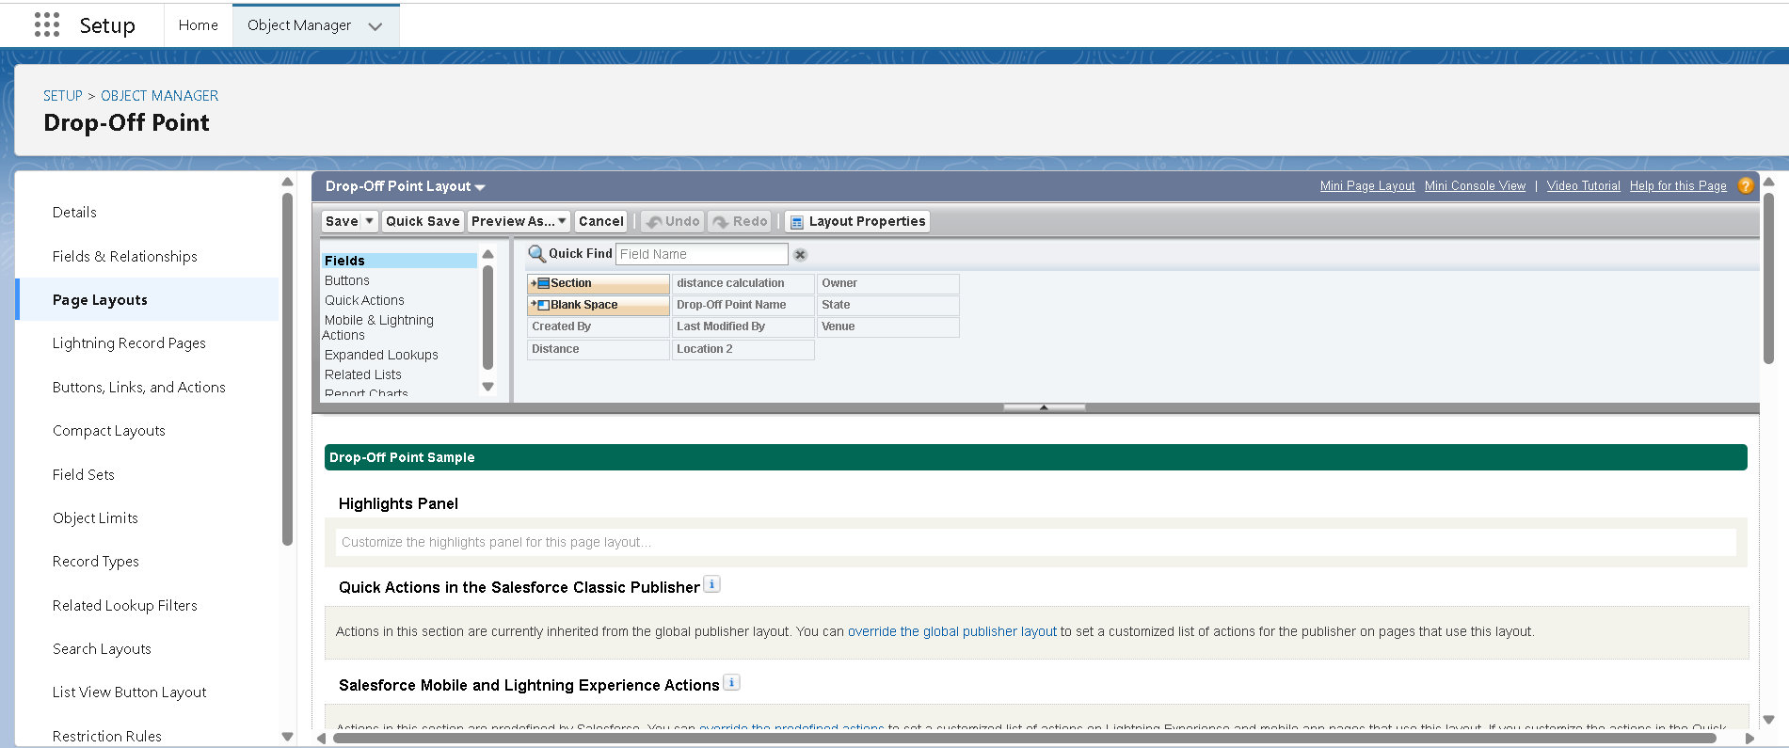

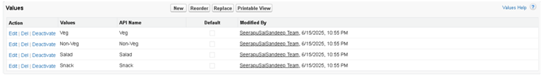

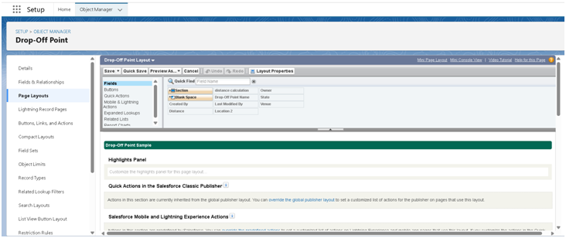

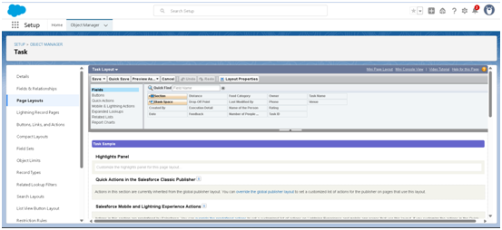

**5. REPORTS & DASHBOARDS**

**A. Custom Reports**

|  |  |  |
| --- | --- | --- |
| **Report Name** | **Type** | **Fields Included** |
| Donations by Category | Summary | Donor, Item Category, Quantity |
| Volunteer Assignment Summary | Tabular | Volunteer, No. of Pickups, Area Assigned |
| Daily Delivery Report | Matrix | Date, Delivered_To, Volunteer |

**B. Dashboards**

|  |  |  |
| --- | --- | --- |
| **Dashboard Component** | **Chart Type** | **Description** |
| Total Food Donated | Metric | Displays total donated quantity |
| Deliveries by Area | Pie Chart | Visual of how food is distributed |
| Volunteers Active Today | Bar Chart | Shows volunteers currently assigned tasks |
|  |  |  |
|  |  |  |

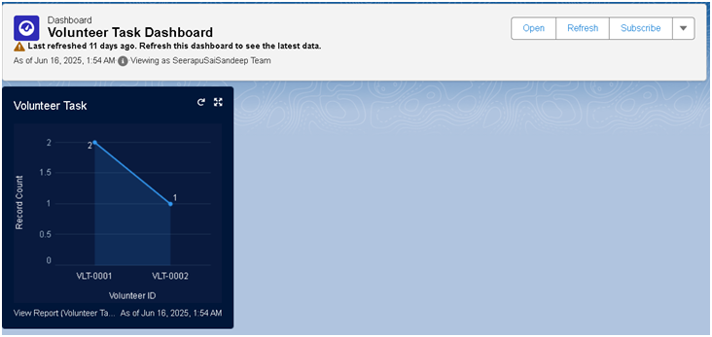

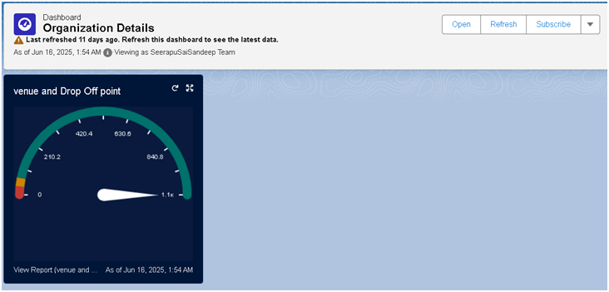

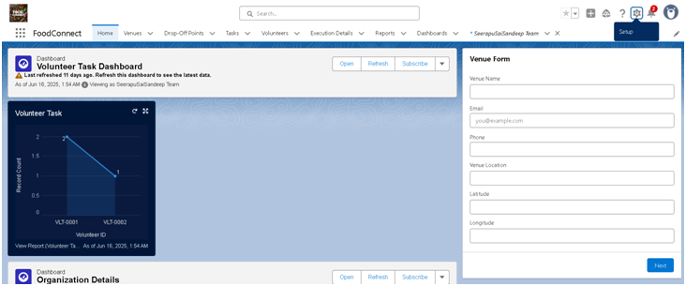

**6. USER PROFILES AND PERMISSIONS**

|  |  |
| --- | --- |
| **Profile Name** | **Access Details** |
| Donor | Can create/view their own donation records |
| Volunteer | Can view assigned pickup/delivery records; limited edit rights |
| Admin | Full access to all records and automation setup |

**7. ROLE HIERARCHY**

|  |  |  |
| --- | --- | --- |
| **Role** | **Reports To** | **Access Scope** |
| Admin | CEO | Full access |
| Volunteer | Admin | Only records assigned to them |
| Donation Manager | Admin | Access to all donor and food records |

**8. SAMPLE DATASET**

**Donors**

|  |  |
| --- | --- |
| **Name** | **Email** |
| Dinesh Ketana | dinesh@gmail.com |
| Sai Govardhan | govardhan@gmail.com |

**Food Items**

|  |  |  |  |
| --- | --- | --- | --- |
| **Item Name** | **Category** | **Quantity** | **Donor** |
| Veg Rice | Perishable | 5 plates | Dinesh Ketana |
| Bread Packets | Non-Perish | 10 packs | Sai Govardhan |

**Pickup Requests**

|  |  |  |
| --- | --- | --- |
| **Pickup Date** | **Volunteer** | **Donor Location** |
| 17-June | Kol Mikaelson | Ameerpet |

**Deliveries**

|  |  |  |
| --- | --- | --- |
| **Delivered To** | **Volunteer** | **Delivery Date** |
| Mother Teresa NGO | Kol Mikaelson | 18-June |

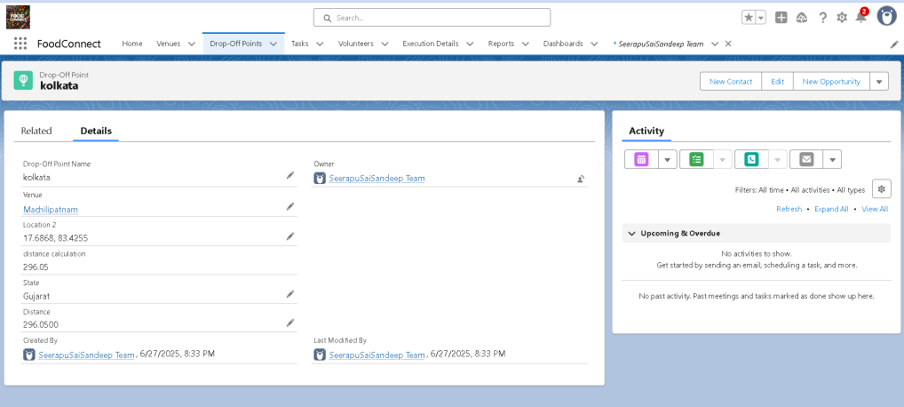

**9. DEPLOYMENT PROCESS**

* **Development Environment:** Salesforce Sandbox
* **Deployment Tool:** Change Set
* **Steps:**
  1. Created outbound change set with all components.
  2. Uploaded and validated in Production Org.
  3. Deployed and tested with sample records.

**10. BENEFITS & IMPACT**

* **Streamlined food collection & delivery**
* **Automated email notifications reduce manual effort**
* **Data reports help identify areas needing more support**
* **Scalable system to onboard more donors and volunteers**